1. Greenbank
   1. The mechanism for the emission that we observed from the Milky Way disk was the 21-cm emission line of hydrogen, as well as the doppler shift mechanism. This emission line from the hyperfine transition of the hydrogen 1s ground state. It is called the spin-flip transition because this 21-cm photon is released when the proton-electron pair flips from the higher-energy parallel spins to the lower-energy anti-parallel spins.
   2. The 21-cm hydrogen emission line described previously corresponds to a vacuum frequency of 1.42GHz. However, the equipment that eventually connects to the Chart Recorder cannot measure such high frequencies, it can only measure frequencies of a few hundred MHz. Instead, we must mix the signal with a constant signal at 1.32 GHz, lowering the 1.42GHz frequency to about 100MHz. If our goal is to measure the doppler distribution of the Milky Way spectrum, we must measure the sky in multiple frequencies. This is done by modulating the Local Oscillator (LO) frequency to our desired frequency (minus 100MHz, remember the mixer), and slowly changing the frequency within our desired range. This will plot on the chart recorder the intensity vs. wavelength of the Milky Way disk.
2. CCDs
   1. Using an insulator would make the bandgap between the conduction and valence bands too wide to traverse for a detection electron. Making it too difficult to detect any hits. Using a conductor would cause an overlap between the conduction and valence bands, making the instrument too sensitive to reliably collect data. A semiconductor is ‘just right’ allowing detection of good hits without too much noise.
   2. 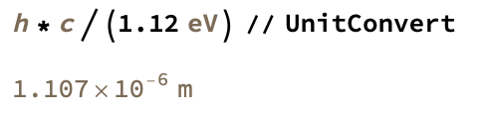 $=1.1µm$
      1. Might work for near-IR light, but since IR goes from .7µm to 1000µm, it would only be able to detect the first ≈.4µm or so
   3. 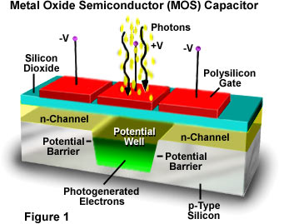
      1. The idea of CCDs are to have many little “light buckets” that can capture photons in different positions, and then read out the counts sequentially to generate an image. What the Metal Oxide Semiconductor Capcitors do are exactly this. The Polysilicon Gates are oriented perpendicular to the readout direction. The high potential barrier means that the electrons in each “bucket” do not leak into the next, thus allowing definitive images to form. Additionally, the SO­2 layer creates gate voltages that allows the sequential readout of counts in each “bucket”.
   4. 1.3s
 $1.66*{10}^{-2}$

  5. Quantum efficiency is the fraction of photons that hit the detector vs. how many photons are measured.
3. 1. 21.54
   2. 12.52
   3. Read noise dominates part a, and moon brightness dominates part b
4. 1. The number of photons hitting the detector, the quantum efficiency of the CCD, the gain of the CCD
5. Photometry
   1. K=0.0333,
6. 1. .5nm
   2. 1100
   3. 64nm
7. 1. 89%
8. Dark current
   1. 87410 (units?)
   2. 117.96 (units?)
9. Gain
   1. .22
   2. .0026

Bonus: For a new student to this course, I would suggest them attempting a similar project to mine, but without the mistakes or potholes I fell into while doing this research. Perhaps a planet with a more interesting atmosphere would be good too, like Jupiter. For an observation such as this, it would only be necessary to do a single night of observing but doing multiple nights would be better. Given the brightness of Jupiter, doing many short-term exposures is optimal. No more than 10 seconds or so per exposure and try to get as many exposures as you can. The Sun has a wide spectrum, and you want to be able to get all of that to support the hypothesis, so getting many different calibration frames in different wavelengths is critical. And for general advice (not specific to this project), I would urge any new students to keep very detailed observing logs, and make sure to take all the required calibration frames necessary.